Flower Haiku
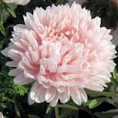

The spring pink flower
Sun wakes the winter bloom
Displays God’s creation

As I looked at the flower I noticed the soft pink color and how peaceful it looked. Through my haiku I wanted to choose words that would describe its simplistic but yet beautiful God given design.

